**Cross-Validation Results on Last 50 Training Data:**

Elastic Net (Linear Regression):

[0.77322432 0.85262059 0.6381798]

Random Forest Regression:

[0.76109305 0.73661917 0.74360336]

Support Vector Regression (kernel: rbf):

[-0.00176979 -0.05324072 -0.00227957]

Neural Network:

[0.69225911 0.64298264 0.36656642]

**Test Data Accuracy Scores:**

Elastic Net (Linear Regression):

0.8284457626065779 10.0 1.0

Random Forest Regression:

0.8432213629252402 35

Support Vector Regression:

-0.008976999015341436 100000.0

Neural Network:

0.7163912499248521 90 identity

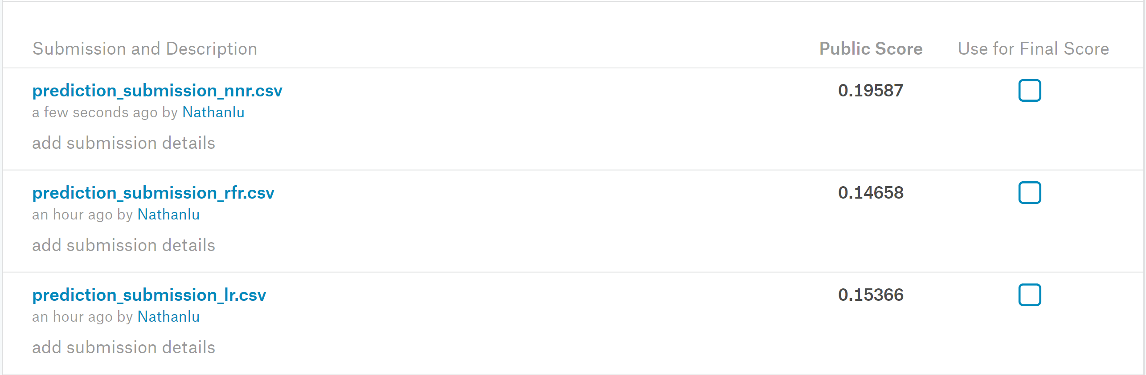

**Performed Error Analysis and Transformed/Corrected Some Features:**

Elastic Net (Linear Regression):

[0.76572227 0.74042041 0.53014883]

Random Forest Regression:

[0.71651379 0.71294388 0.75306159]

Support Vector Regression (kernel: rbf):

[-0.00262505 -0.05426341 -0.00213522]

Neural Network:

[0.58661918 0.37845757 0.17211903]

**Test Data Accuracy Scores:**

Elastic Net (Linear Regression):

0.8337159078802087 10.0 1.0

Random Forest Regression:

0.8268787508721124 35

Support Vector Regression:

-0.00808064796716701 100000.0 rbf

Neural Network:

0.5586372329062902 50 identity



**Back to Original and Only Transforming Year of Built/Remod/Garage Built:**

Elastic Net (Linear Regression):

[0.79875509 0.82511075 0.65615075]

Random Forest Regression:

[0.7584552 0.73246424 0.75120739]

Support Vector Regression:

[-0.00176579 -0.05323579 -0.00228024]

Neural Network:

[0.65548808 0.66340302 0.37332946]

**Test Data Accuracy Scores:**

Elastic Net (Linear Regression):

0.8297046781127434 10.0 1.0

Random Forest Regression:

0.8441005163568448 45

Support Vector Regression:

-0.0075005846743107325 100000.0 rbf

Neural Network:

0.6435711105281609 30 relu

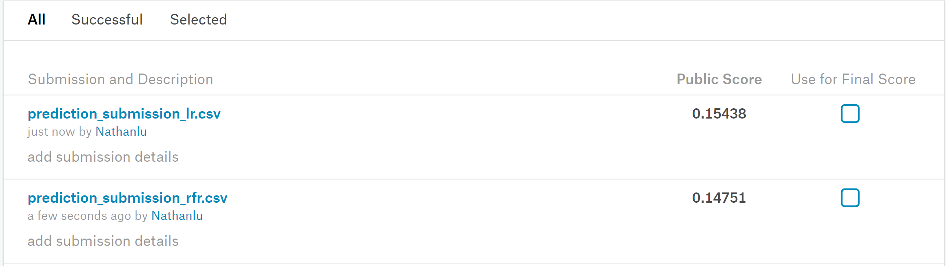

**After Implementing Mean Normalization and Learning Curves:**

Learning Curves: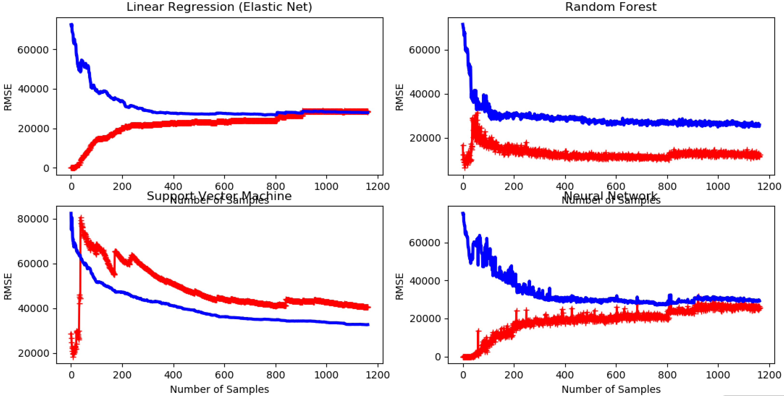

Random forest seems overfitting (however, performing not too bad on both training and cv data), while SVM shows a weird pattern (performing poorly in both training and cv data). The other two seem just fine. SVM is therefore excluded from further consideration.

Elastic Net (Linear Regression):

0.8075318696652626 0.1 0.95

[0.78373605 0.78829487 0.74773552]

Random Forest Regression:

0.835947929908206 30

[0.81619088 0.81803885 0.73153284]

Support Vector Regression:

0.6939219507579883 100000.0 rbf

[0.50821507 0.52574541 0.53446228]

Neural Network:

0.7807292214263658 20 identity

[0.72329063 0.72907805 0.76306614]

**After Implementing Mean Normalization and Learning Curves:**

Learning Curves:

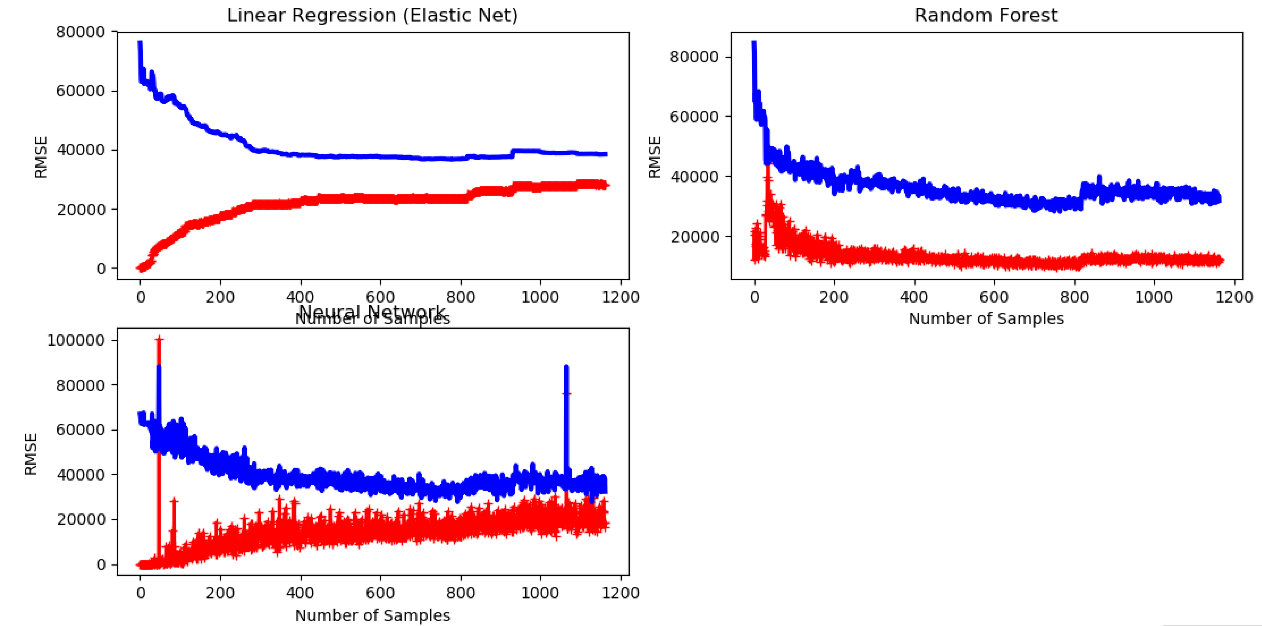

Elastic Net (Linear Regression):

0.803028866530811 0.16237767391887217 0.95

[0.73370066 0.78928794 0.76622373]

Random Forest Regression:

0.8382081368682309 30

[0.79781078 0.79464928 0.7955397]

Neural Network:

0.7867917185510072 10 relu

[0.77817954 0.79387492 0.72047959]

**Test Data Accuracy Scores:**

